Design of Two-Band Digital Crossover Using FIR Filtering Concepts

Manje Sushanth  
Electrical Department *Indian Institute of Technology Palakkad*Palakkad, India  
122001025@smail.iitpkd.ac.in

*Abstract*— In this document, a Two Band Digital Crossover is designed using FIR filtering concepts. Digital Crossovers are widely used in modern audio systems for separating audio signals into multiple frequency bands, these frequency bands can be sent into different amplifiers or speakers (such as woofers and tweeters). FIR filters have many advantages over other filtering techniques like easy implementation using digital signal processing techniques. Using, FIR filtering concepts, a Low Pass filter and an High Pass Filter is designed. Then, the frequency response of the designed low pass and high pass filters and the plot of their coefficients have been obtained. The incoming digital audio signal is split into two bands using these designed low pass filter and high pass filter in parallel. Then, the spectrum of the original signal and the spectrum of the signal after passing through LPF and HPF have been obtained. Generally, we will have two speaker drivers where the woofer responds to low frequencies and the tweeter responds to high frequencies.

Keywords— Two Band Digital Crossover, FIR Filtering, Low Pass Filter, High Pass Filter, Woofer, Tweeter

# Introduction

Finite Impulse Response (FIR) filters have many applications and one of the applications is Digital Crossover. Generally, in audio system applications, we find a situation where the application needs the entire audible range of frequencies. But, a single speaker driver doesn’t have this capability. So, we combine several speaker drivers in order to cover the different frequency ranges to produce full audio frequency range. Generally, a two-band digital crossover has two speaker drivers. The tweeter is used to respond to high frequencies and the woofer responds to lower frequencies. We will split the incoming digital signal into two bands by using low pass and high pass filter in parallel and send the low pass band to woofer and send the high pass band to tweeter. So, we can make use of FIR filtering methods to design Low Pass and High Pass filters for a specified crossover frequency so that the combined response of these two filters is flat while keeping the transition in these filters as sharp as possible to prevent audio signal distortion in the range of the transition frequency. Traditionally, crossovers are designed using active and passive circuits, but our digital crossover system is cost effective and is flexible, has high quality over the traditional methos. Our system is also programmable.

## Major Contibution

* Design of Low pass and High Pass Filter – Manje Sushanth (Myself)
* FIR Filtering Concepts – Learnt from Digital Signal Processing Fundamentals and Applications book by LiTan

## Organization of the Paper

In this paper in Section II, subsection A discusses about the concepts of FIR filtering, then Proposed method to design is discussed in B where the method to design filters using FIR filtering concepts is focused. Then in section C we have source code. Finally, in section III the results have been shown and the paper is concluded in IV.

# Materials and METHODS

## Concepts of FIR Filters

Finite Impulse Response Signal: - It can be defined as a signal whose impulse response has finite length.

Finite Impulse Response (FIR) Filter: - It can be defined as a filter whose impulse response has finite duration. The following input-output relation specifies the FIR filter completely.

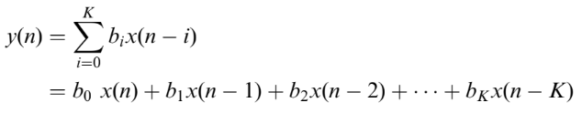 (1)

Here, bi represents FIR filter coefficients and filter length is given by K+1. We can apply the Z Transform on both sides of (1) and can obtain the following Transfer function.

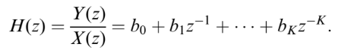 (2)

Using the above equation we can design various filters like Low Pass Filter, High Pass Filter, Band Pass Filter, Band Stop Filter which can be used in digital crossover. These FIR filtering concepts can also be used in real world applications like noise reduction in audio applications.

Other filtering techniques like IIR (Infinite Impulse Response) filtering techniques are also available. The advantages of FIR filtering techniques over other techniques are: - It doesn’t require feedback, It is inherently stable as its output is sum of finite multiples of input values which are also in finite number. Also, Linear Phase can be easily realized by making the coefficient sequence symmetric. In the following section we will see how to design the filters using FIR filtering techniques.

## Proposed Method

The method proposed is to design a Low Pass and a High Pass Filter and send the incoming digital audio signal into it parallelly and split the signal into two bands. The band from LPF goes into woofer and the band from HPF goes into Tweeter.

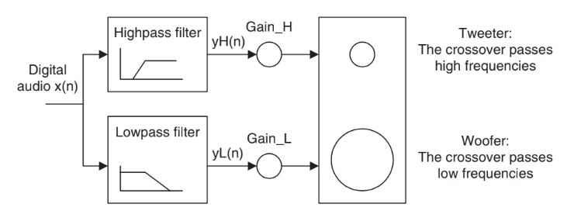

Figure 1: Block diagram of the proposed Two-Band Digital Crossover

***Design of Low Pass Filter block using FIR filtering techniques: -***

Let us start with a ideal low pass filter which has a normalized cut off frequency Ωc. Then the frequency response is characterized by the equation: -

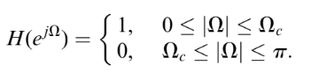 (3)

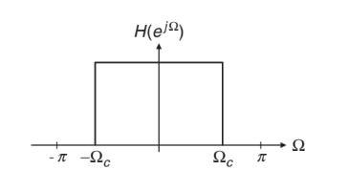

Figure 2: Frequency response of an ideal low pass filter

This frequency response is periodic with a periodicity of 2π, we can extend (3) to other Ω also. Now, we will approximate this frequency response using complex fourier series expansion as: -

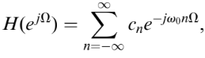 (4)

The fourier coefficients in the above equation are given by: -

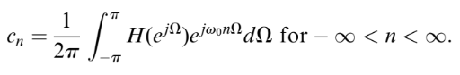 (5)

The fundamental frequency ω0 is 1(2π/period of LPF

waveform). Plugging this into (5) and then introducing h(n) = cn, which is called desired impulse response of ideal filter, we get the FT design as: -

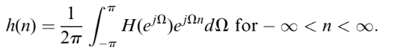 (6)

Now to obtain transfer function in terms of z, we substitute $e^{jω}$ as z and ω0 as 1, we get:-

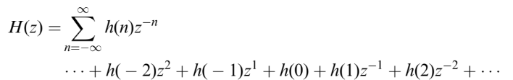(7)

The above equation is Non - Causal filter. It can be converted into causal. By using the Fourier Transform design in (6), the ideal low pass filter is: -

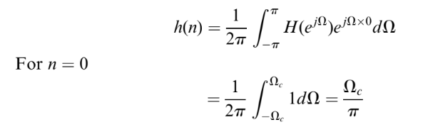 (8)

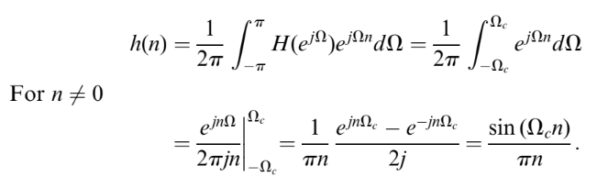(9)

Where, Ωc is the normalized cutoff frequency.

Similarly, using the above FIR concepts a High pass filter block can also be designed. The high pass filter using FIR filtering concepts yields the following result: -

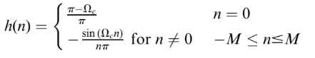(10)

Where, M is the filter length.

So, finally we have the following impulse responses for the Low pass and High pass filters: -

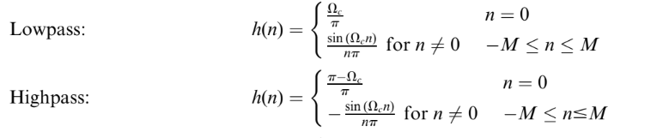(11)

The above filters designed are for non-causal filters. It can be made causal by shifting h(n) to the right by M samples. In the implementation of these filters, causal filters are used.

## Source Code

*#Importing the necessary libraries*

*import numpy as np*

*import matplotlib.pyplot as plt*

*from scipy.io import wavfile*

*from scipy import signal;*

*# Reading the audio file*

*audio = "/content/25803493_short-violin-ad-ident_by_groovinggecko_preview.wav"*

*fs,in_signal = wavfile.read(audio)*

*# The sampling rate (in Hz)*

*print("The sampling rate = ",fs," Hz")*

*# The Crossover Frequency (in Hz)*

*fc = 5000*

*# Number of taps of filter (Filter order)*

*N = 183*

*# Creating the low pass filter*

*#Initializing with zeroes*

*h_lp = np.zeros(N)*

*# Creating the causal LPF*

*for n in range(N):*

*if n == (N-1)//2:*

*h_lp[n] = 2*fc/fs*

*else:*

*h_lp[n] = np.sin(2*np.pi*fc*(n-(N-1)//2)/fs)/(np.pi*(n-(N-1)//2))*

*# Creating the High pass filter*

*#Initializing with zeroes*

*h_hp = np.zeros(N)*

*#Creatnig the causal HPF*

*for n in range(N):*

*if n == (N-1)//2:*

*h_hp[n] = 1-2*fc/fs*

*else:*

*h_hp[n] = -np.sin(2*np.pi*fc*(n-(N-1)//2)/fs)/(np.pi*(n-(N-1)//2))*

*in_signal1 = np.ndarray.flatten(in_signal)*

*# Convolving the signal with low pass filter*

*y_lp = np.convolve(h_lp,in_signal1)*

*#Convolving the signal with high pass filter*

*y_hp = np.convolve(h_hp,in_signal1)*

*# Frequency response of the created filters*

*w, H1 = signal.freqz(h_lp, 1, fs=fs)*

*_, H2 = signal.freqz(h_hp, 1, fs=fs)*

*# plotting the frequency response of the filters*

*# Low Pass*

*plt.plot(w, 20*np.log10(np.abs(H1)), 'b-', label='Low-pass')*

*# High Pass*

*plt.plot(w, 20*np.log10(np.abs(H2)), 'r-', label='High-pass')*

*plt.xlim(0, 10000)*

*plt.ylim(-60, 10)*

*plt.xlabel('Frequency (Hz)')*

*plt.ylabel('Magnitude (dB)')*

*plt.ylim(-30,20)*

*plt.grid(True)*

*plt.legend()*

*plt.title('Frequency Response of Filters')*

*plt.show()*

*# plotting the filter coefficients*

*# For the Low Pass Filter*

*fig, ax = plt.subplots(2, 1, figsize=(8, 6))*

*ax[0].stem(h_lp, use_line_collection=True)*

*ax[0].set_xlabel('Tap index')*

*ax[0].set_ylabel('Amplitude')*

*ax[0].set_title('Low-pass Filter Coefficients')*

*ax[0].grid(True)*

*#For the High Pass Filter*

*ax[1].stem(h_hp, use_line_collection=True)*

*ax[1].set_xlabel('Tap index')*

*ax[1].set_ylabel('Amplitude')*

*ax[1].set_title('High-pass Filter Coefficients')*

*ax[1].grid(True)*

*fig.tight_layout()*

*plt.show()*

*# Plotting the spectrum of the original signal*

*plt.magnitude_spectrum(in_signal1, Fs = fs)*

*plt.xlabel('Frequency')*

*plt.ylabel('Magnitude')*

*plt.title('Specturm of the audio signal')*

*plt.grid(True)*

*plt.show()*

*# Plotting the spectrum of signal after passing it through LPF*

*plt.magnitude_spectrum(y_lp, Fs = fs)*

*plt.xlabel('Frequency')*

*plt.ylabel('Magnitude')*

*plt.title('Specturm of the audio signal after passing it through LPF')*

*plt.grid(True)*

*plt.show()*

*# Plotting the spectrum of signal after passing it through HPF*

*plt.magnitude_spectrum(y_hp, Fs = fs)*

*plt.xlabel('Frequency')*

*plt.ylabel('Magnitude')*

*plt.title('Specturm of the audio signal after passing it through HPF')*

*plt.grid(True)*

*plt.show()*

# Results

For the simulations crossover frequency of 5000 Hz was chosen and a sampling rate of 44100 was taken. A sample audio was taken and is analyzed. We have to include the file path in our input signal to analyze our desired signal. The following results were obtained from the above source code.

## Figures

#### 

Figure 3: Frequency response of the low pass and the high pass filter

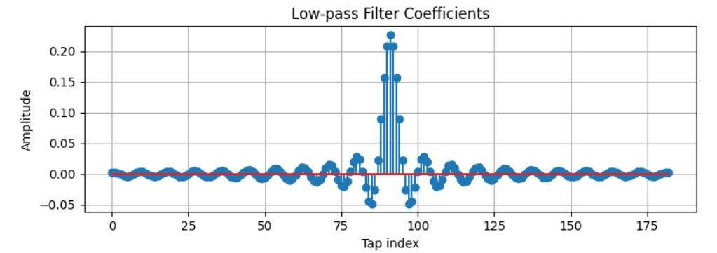

Figure 4: Plot of Low Pass Filter Coefficients

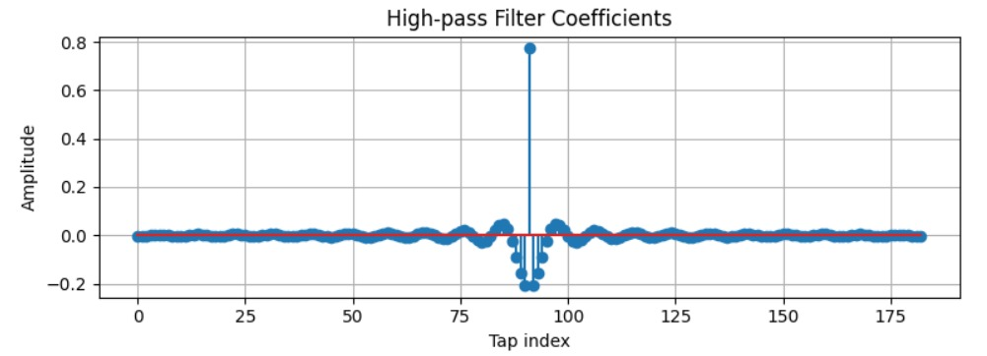

Figure 5: Plot of High Pass Filter Coefficients

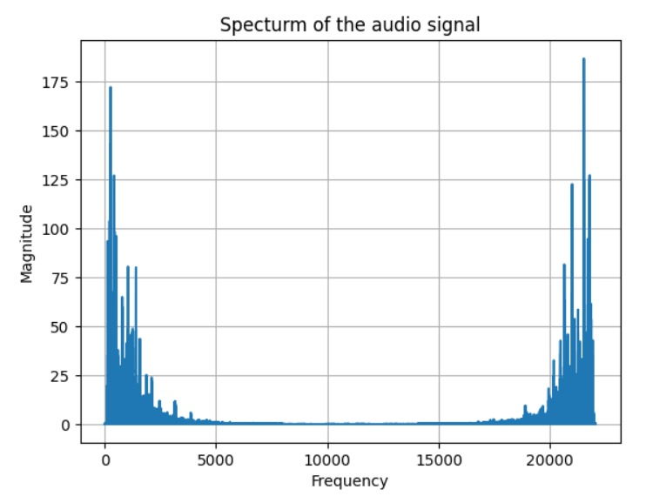

Figure 6: Spectrum of the audio signal

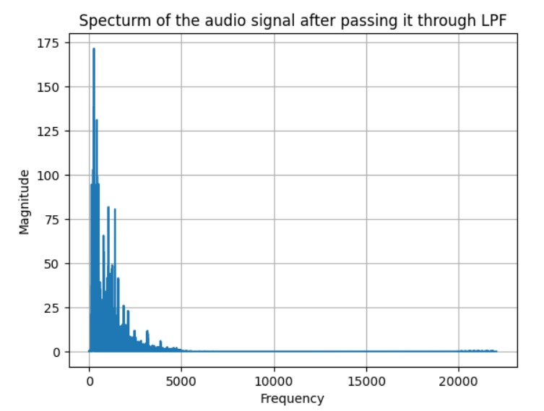

Figure 7: Spectrum of the audio signal after passing it through LPF

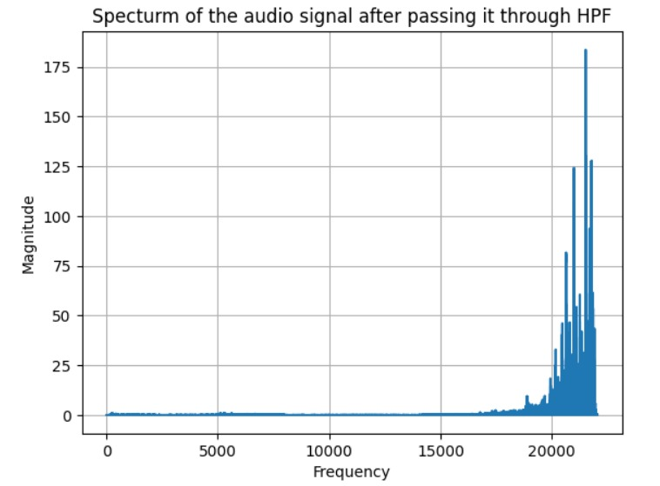

Figure 8: Spectrum of the audio signal after passing it through HPF

From figure 3, we can observe that the crossover frequency is 5000 Hz. After passing through LPF we can observe that in figure 7, all the frequency components after 5000 Hz are nullified and in figure 8, we can observe that all the frequency components below 5000 Hz are nullified.

IV. CONCLUSIONS

Finally, we can conclude that using FIR filtering concepts a two-band digital crossover filter with crossover frequency of 5000 Hz is designed. The cut off frequency of low pass and high pass filters is 5000 Hz. The coefficients of both low pass and high pass filters have been plotted. The spectrum of the original signal and the signal after passing it through Low pass filter and High Pass filter have been plotted. It is observed that in the spectrum of signal after passing through LPF all components after 5000 Hz are nullified and for HPF all components below 5000 Hz are nullified .The signal from LPF is sent to a woofer and the signal from HPF is sent to tweeter. So, we can conclude that FIR filtering concepts are very useful in daily life applications.

##### References

1. Digital Signal Processing – Fundamentals and Applications by Li Tan.
2. Wikipedia – Finite Impulse Response.
3. Digital Signal Processing – Principles, Algorithms & Applications by John G. Proakis.
4. EE3020 Digital Signal Processing Course Presentation Slides – By Dr.Sabarimalai Manikandan.